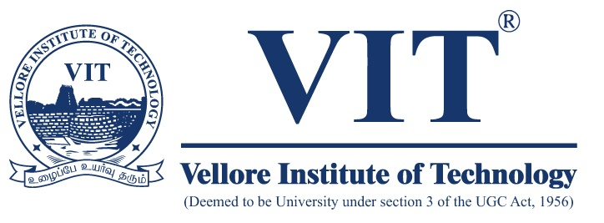

**INTRODUCTION TO INNOVATIVE PROJECTS**

FACULTY – Dr. ATANU DUTTA

**TOPIC**

LI-FI HARD DISK AND DATA TANSMISSION USING LI-FI

**TEAM MEMBERS**

SAMUDRANIL GIRI - 17BCE1110

SOUBHIK MAZUMDAR - 17BEC1020

DEBARPAN MAZUMDER - 17BEC1002

ARKA KUMAR - 17BLC1109

SOUMODEEP PAUL - 17BLC1176

**TEAM MEMBERS**

SAMUDRANIL GIRI - 17BCE1110

SOUBHIK MAZUMDAR - 17BEC1020

DEBARPAN MAZUMDER - 17BEC1002

ARKA KUMAR - 17BLC1109

SOUMODEEP PAUL - 17BLC1176

**INTRODUCTION**

Li-Fi (short for light fidelity) is a technology for [wireless communication](https://en.wikipedia.org/wiki/Wireless) between devices using light to transmit data. In its present state only [LED lamps](https://en.wikipedia.org/wiki/LED_lamp) can be used for the transmission of visible light. The term was first introduced by [Harald Haas](https://en.wikipedia.org/wiki/Harald_Haas_(engineer)) during a 2011 [TED Global](https://en.wikipedia.org/wiki/TED_(conference)) talk in [Edinburgh](https://en.wikipedia.org/wiki/Edinburgh). In technical terms, Li-Fi is a [visible light communications](https://en.wikipedia.org/wiki/Visible_light_communication) system that is capable of transmitting [data](https://en.wikipedia.org/wiki/Data) at high speeds over the [visible light spectrum](https://en.wikipedia.org/wiki/Visible_spectrum), [ultraviolet](https://en.wikipedia.org/wiki/Ultraviolet) and [infrared](https://en.wikipedia.org/wiki/Infrared) radiation.

In terms of its [end use](https://en.wikipedia.org/wiki/End_user) the technology is similar to [Wi-Fi](https://en.wikipedia.org/wiki/Wi-Fi). The key technical difference is that Wi-Fi uses [radio frequency](https://en.wikipedia.org/wiki/Radio_frequency) to transmit data. Using light to transmit data allows Li-Fi to offer several advantages like working across higher [bandwidth](https://en.wikipedia.org/wiki/Bandwidth_(signal_processing)), working in areas susceptible to electromagnetic interference (e.g. [aircraft cabins](https://en.wikipedia.org/wiki/Aircraft_cabin), hospitals) and offering higher transmission speeds. The technology is actively being developed by several organisations across the globe.

THE TECHNOLOGY:

[Visible light communications](https://en.wikipedia.org/wiki/Visible_light_communication) (VLC) works by switching the current to the LEDs off and on at a very high rate, too quick to be noticed by the human eye. Although Li-Fi LEDs would have to be kept on to transmit data, they could be dimmed to below human visibility while still emitting enough light to carry data. The light waves cannot penetrate walls which makes a much shorter range, though more secure from hacking, relative to Wi-Fi.

Li-Fi involves transmission of data through illumination by taking the fiber out of fiber optics by sending data through a LED light bulb that varies in intensity faster than the human eye can follow. By flickering the light within ON and OFF phases you can transfer data as 1’s and 0’s respectively. The switching is done at such a high rate that it remains unphased to the human eye. This gives an advantage over present wireless means of data as it is cost effective, consumes lower amounts of energy, is faster upto 70MBits/s.

HARD DISK:

A hard disk drive (HDD), hard disk, hard drive or fixed disk is a [data storage device](https://en.wikipedia.org/wiki/Data_storage_device) that uses [magnetic storage](https://en.wikipedia.org/wiki/Magnetic_media) to store and retrieve [digital](https://en.wikipedia.org/wiki/Digital_data) information using one or more rigid rapidly rotating disks ([platters](https://en.wikipedia.org/wiki/Hard_disk_platter)) coated with magnetic material. The platters are paired with [magnetic heads](https://en.wikipedia.org/wiki/Disk_read-and-write_head), usually arranged on a moving [actuator](https://en.wikipedia.org/wiki/Actuator) arm, which read and write data to the platter surfaces. Data is accessed in a [random-access](https://en.wikipedia.org/wiki/Random-access) manner, meaning that individual [blocks](https://en.wikipedia.org/wiki/Block_(data_storage)) of data can be stored or retrieved in any order and not only [sequentially](https://en.wikipedia.org/wiki/Sequential_access). HDDs are a type of [non-volatile storage](https://en.wikipedia.org/wiki/Non-volatile_storage), retaining stored data even when powered off.

Introduced by [IBM](https://en.wikipedia.org/wiki/IBM) in 1956, HDDs became the dominant [secondary storage](https://en.wikipedia.org/wiki/Secondary_storage) device for [general-purpose computers](https://en.wikipedia.org/wiki/History_of_general-purpose_CPUs) by the early 1960s. Continuously improved, HDDs have maintained this position into the modern era of [servers](https://en.wikipedia.org/wiki/Server_(computing)) and [personal computers](https://en.wikipedia.org/wiki/Personal_computer). More than 200 companies have produced HDDs historically, though after extensive industry consolidation most current units are manufactured by [Seagate](https://en.wikipedia.org/wiki/Seagate_Technology), [Toshiba](https://en.wikipedia.org/wiki/Toshiba), and [Western Digital](https://en.wikipedia.org/wiki/Western_Digital). HDD unit shipments and sales revenues are declining, though production (exa bytes per year) is growing. [Flash memory](https://en.wikipedia.org/wiki/Flash_memory) has a growing share of the market for secondary storage, in the form of [solid-state drives](https://en.wikipedia.org/wiki/Solid-state_drive) (SSDs). SSDs have higher data-transfer rates, higher areal storage density, better reliability, and much lower latency and access times. Though SSDs have higher cost per bit, they are replacing HDDs where speed, power consumption, small size, and durability are important.

THE TECHNOLOGY BEHIND HARD DISK:

A modern HDD records data by magnetizing a thin film of [ferromagnetic material](https://en.wikipedia.org/wiki/Ferromagnetic_material) on a disk. Sequential changes in the direction of magnetization represent binary data [bits](https://en.wikipedia.org/wiki/Bit). The data is read from the disk by detecting the transitions in magnetization. User data is encoded using an encoding scheme, such as [run-length limited](https://en.wikipedia.org/wiki/Run-length_limited) encoding, which determines how the data is represented by the magnetic transitions.

A typical HDD design consists of a spindle that holds flat circular disks, also called [platters](https://en.wikipedia.org/wiki/Hard_disk_platter), which hold the recorded data. The platters are made from a non-magnetic material, usually aluminium alloy, glass, or ceramic, and are coated with a shallow layer of magnetic material typically 10–20 [nm](https://en.wikipedia.org/wiki/Nanometer) in depth, with an outer layer of carbon for protection. For reference, a standard piece of copy paper is 0.07–0.18 millimeters (70,000–180,000 nm).

PHOTODIODE:

The photodiode is a semiconductor converting light into an electrical current. Most of the photodiodes in the market are produced for the purpose of fibre optics. In applications concerning fibre optics, the radiant sensitive area of the photodiode is small and the rise/fall time is short. With increased radiant sensitive area, the response time will be slower. Without fibre optics a larger radiant sensitive area allows for more light to be captured by the receiver. Therefore, the choice of photodiode is limited. The requirements of the photodiode are quick response time, spectral sensitivity in the visible spectrum and large radiant sensitive area. It has suitable wavelength peak sensitivity at 565 nm. The spectral bandwidth is from 420 nm to 675 nm and gives a perfect range for the intended application. It has a linear light intensity to current ratio and the radiant sensitive area is 7.5 mm2, which was larger than most photodiodes found. It has a rise and fall time of 3 μs each, which provides a switching frequency of 166 kHz.

**WHY INNOVATION REQUIRED**

Large scale Losses Due to lack of li-fi: Beyond the cost of your employees not being able to do their work in an efficient manner, slow internet causes pain and lost profits. For example, a delay in the responsiveness of your company's CRM system negatively impacts your customer's experience. If your competitors have a faster more efficient network they are able to respond quicker to customer inquiries and ultimately sell more widgets.

If your company operates an e-commerce site, slow internet can be very costly. Google maintains that pages that load four tenths of a second slower lose searches, resulting in decreased web traffic. If your page loads too slow most people won't wait around. They will click off your page and head over to a competitor page.

You’ve probably noticed files are getting bigger. Hard drives are getting bigger. Databases are getting bigger. [The amount of stuff that we’re digitizing and recording is increasing](http://www.economist.com/node/15557443). And business processes are getting more and more digital with lots of attributes, photos, and contributors offering updates and details. But how does this data get moved around?

There exists a large gap in the marketplace when it comes to [high-speed data transfer](http://www.cleo.com/solutions/high-speed-file-transfer/). Some companies say they can transmit your data fast, but how fast is fast? Is it reliable? How will you know if it gets to where it needs to go? Factor in the prevailing nature of global file transfer across multiple networks and the need to optimize bandwidth usage for everyday business functions, and managing data flows at a high velocity becomes more challenging than ever.

Consider a lengthy road trip. Type your destination into [Google Maps](http://www.pcmag.com/slideshow/story/328592/18-google-maps-tricks-you-need-to-try), check out the various routes, and determine which route is best for your trip. The fastest route generally wins out, and condensing this transit duration often means:

Less time cooped up in a vehicle

Less anxiety about actually getting to your destination using established, well-maintained roads

Fewer chances of having issues on the road, with the kids in the car, etc.

More productivity and time spent enjoying the destination

In this scenario, choosing the fastest destination might mean you miss out on some anticipated side trips or some great scenery. But in the data world, there’s not much room for scenery when speed and reliability actuate the bottom line.

A large file in motion can stall productivity, and the chance for transfer error is magnified as the file size grows. Reduce these transfer errors and:

Improve business velocity to reduce risk and increase competitiveness

Recover from operational challenges more quickly

Exceed more stringent service-level agreements with your customers

**WHAT INNOVATION**

Li-Fi can play a major role in relieving the heavy loads which the current wireless systems face since it adds a new and unutilized bandwidth of visible light to the currently available radio waves for data transfer. Thus it offers much larger frequency band (300 THz) compared to that available in RF communications (300 GHz). Also, more data coming through the visible spectrum could help alleviate concerns that the electromagnetic waves that come with Wi-Fi could adversely affect our health. Along with those blazing speeds, Li-Fi offers security benefits beyond strong passwords and AES encryption. Because it uses visible light to transmit data, it can’t pass through walls, making it practically as secure as sharing files with an external Thunderbolt drive. Furthermore, since light waves don’t interfere with other radio signals like Wi-Fi does, it could even be used safely on planes, in hospitals, and in other areas where interference is an issue. Li-Fi, could provide a substantially increased solution to enhance data security to businesses seeking to improve data protection, from government and defence organizations, to financial, public sector, pharmaceutical, or any ‘high data risk’ industries. By exploiting specific properties of light, the Li-Fi system prevents both sides of the communications link being intercepted. What Li-Fi means for the security of public and corporate internet access? Wi-Fi signals propagate in all directions and pass through walls and all data within range can be recorded. Because Li-Fi signals travel in directional beams between an access point and a terminal, and vice versa, a potential interceptor would need to be in the overlapping space of both light beams. Even an unencrypted Li-Fi access point provides better security than Wi-Fi. Li-Fi removes the uncertainty of joining a network. In a typical Li-Fi installation, ceiling lights which transmit and receive the data are part of the premises and this creates a chain of accountability for the security of the users’ data. The inherent security advantages of Li-Fi and the accountability that it offers, provide a supplement to the emerging need for greater data security and responsibility. Arguably the most important criteria of choosing and using the transfer data through internet is the security of the transfer. As we all know, wireless signals delivered by radio waves can go through walls into the outside world, where hackers and other malicious entities might be waiting. Light, on the other hand, can’t pass through walls, which means that it’s more likely to stay secure than a wireless signal broadcast to the entire vicinity. As long as transparent materials like windows are covered, access to a Li-Fi channel is limited to devices inside the room. This raises the possibility of creating secure adhoc networks in meeting rooms for example – enabling participants to share data without risk of data leaking out. Communication only takes place where the light can be seen, therefore the light can be directed towards certain areas within the office. This creates possibilities in open plan offices to create network zones. Maybe one part of the office connects to a project network, alternatively if you walk to another area you are granted public Internet access. On the building infrastructure side, the sender (light bulb) and receiver (sensor) are not necessarily the same device, or even in the exact same spot. Li-Fi can be the technology for the future where data for laptops, smart phones, and tablets will be transmitted through the light in a room. Security would not be an issue because if you can‘t see the light, you can‘t access the data. As a result, it can be used in high security military areas where RF communication is prone to eavesdropping.

**PROPOSAL**

In coming generation Wi-Fi which is a technology for [wireless local area networking](https://en.wikipedia.org/wiki/Wireless_LAN) will be replaced by Li-Fi.

Li-Fi (light fidelity) is a technology for [wireless communication](https://en.wikipedia.org/wiki/Wireless) between devices using light to transmit data.  The key technical difference between Li-Fi and Wi-Fi is that Wi-Fi uses [radio frequency](https://en.wikipedia.org/wiki/Radio_frequency) to transmit data whereas Li-Fi use [visible light communications](https://en.wikipedia.org/wiki/Visible_light_communication) system that is capable of transmitting [data](https://en.wikipedia.org/wiki/Data) at high speeds over the visible light spectrum, ultraviolet and infrared radiation. Using light to transmit data allows Li-Fi to offer several advantages like working across higher [bandwidth](https://en.wikipedia.org/wiki/Bandwidth_(signal_processing)), working in areas susceptible to electromagnetic interference (e.g. [aircraft cabins](https://en.wikipedia.org/wiki/Aircraft_cabin), hospitals) and offering higher transmission speeds.

The exciting thing is the maximum data transfer speed of Wi-Fi is 200 MB per second whereas the maximum transfer speed of Li-Fi is 28 GB per second. The potential for this technology to change everything about the way we use the Internet is huge.

When we run out of storage space in our laptop or mobiles we use an external hard-disk. We transfer the less important data to hard-disk and use it whenever needed.

We tried to mix these two technology and thought what it would be if there exists a hard-disk which can transfer data wirelessly. The first idea strike was Wi-Fi but then thinking Li-Fi was much better because it has a lot higher speed than radio transmission. Then another idea strike us i.e. why not a torch can transmit data. A torch has LEDs (to transmit data), battery (to fulfil energy need) the extra thing which needed is a processor and a storage card. With this we came with an imaginary product: portable Li-Fi hard-disk.

Li-Fi is a concept related to data transmission using light source such as LED. LEDs could transmitted the data via the visible light spectrum. And the transmitted data can be received by a sensor which could be a photodiode.

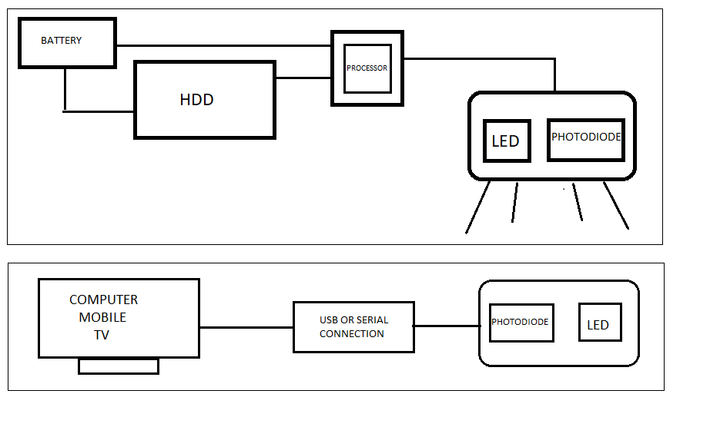

As suggests the block diagram for the overall functioning of the data storage and transfer drive it has few crucial components.

The data sending console i.e. Computer like desktop, laptop, cellular device etc. has data that needs to be transferred. The Li-Fi HDD consist of Li-Fi sensors, storage device, a processing unit and power source. There is a device which will be connected with a laptop or mobile: receives the data from Li-Fi HDD.

There is need of software design to sync all these data together. The hardware is the most essential part of the apparatus with the software playing a minute part in the functioning. The scheduling software is majorly intended to synchronize the data transfer by operating as a gate for the beginning and the end of the data transfer modules.

LEDs are used widely for home lightings. This becomes an advantage to use the product we just introduced.

**OUTCOME**

 Li-Fi. The new internet technology created by Harold Haas. It turns LED lights into internet connection. What if I told you, that Li-Fi will be 100 times faster than Wi-Fi. Li-Fi is affordable as well. It uses LED lights to transmit code to your devices, and with LEDs being pretty cheap, you can put them all over your house.

Advantages of LiFi:

Speed: LiFi provides speeds around 100 times faster than currently achievable speeds in WiFi. Faster communication would result in better service quality and better communication.

Efficiency: LiFi is much more efficient when it comes to cost and power consumption. Since it makes use of LED bulbs for communication, these bulbs can double up as regular lighting for a household reducing power consumption of a LiFi network and making it far efficient than existing technologies alongside not requiring any additional hardware for implementation would reduce the cost of setting up LiFi.

Availability: Due to the use of LED bulbs, LiFi can be made available everywhere by replacing traditional LED bulbs with LiFi compatible bulbs.

Security: Since LiFi makes use of visible light spectrum, it cannot penetrate through optically opaque objects like walls making it difficult for unauthorised access unlike present WiFi which could be accessed from beyond walls and making it vulnerable to unauthorised access.

Our aim is to make a product which is consumer centric. So we focus more on what people need.

At home people use their external hard disk to store data when their system overflow with past stored memory. Past memory could be photos, videos, documents, movies etc. People want to free up their system space and at the same time want to access the previous data simultaneously.

Our product has solution for this domestic problem. As discussed above, we have made a data storage device which transmit data using light and another device which receive and respond to that data. Talking about executing this product we replace the Li-Fi transmitter with lamp and the hard disk is kept at corner of home. This hard disk work as personal server for a family which is hell lot of secure than other means.

The advantage of high speed data transmission and secure personal networking can also be used in company’s own data server. If conventional Wi-Fi and wired communication is replaced by Li-Fi communication then their work speed will increase, now the data will be more secure and they’ll save more energy as Li-Fi serve dual purpose of illuminating the room and transmitting data.

FINAL PROTOTYPE:

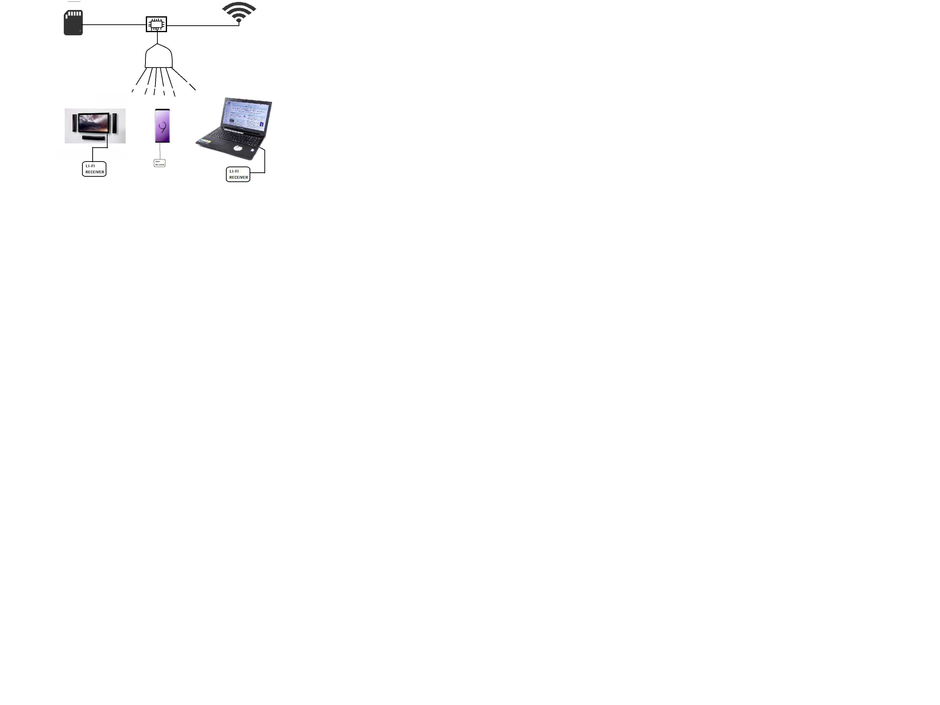

**CONCLUSION**

The modern era has mobility as it is main aim. People need higher power and processing in small packages.

Newer innovations are processed almost every day and most of them get shoved under the rug as most people don’t pay attention to them.

Li-Fi is one such new technology that has come to light in recent times which have a lot of applications but are not being ventured into due to lack of awareness.

By creating this new hard disk powered by li-fi and spreading it’s awareness, we want to change the whole complexion of data transmission and take it to a new level which will bring a collusive improvement in the lifestyle of human beings.

REFERENCES:

* Li-Fi technology and the new concept of data transfer security by Ramona Dumitrascu.
* <http://www.mibqyyo.com/en-articles/2016/03/15/the-bright-future-of-li-fi/>
* <https://en.wikipedia.org/wiki/Li-Fi>